ADMS + Att2008 Data Synchronization Solution
- Purpose
Sir, as we know that, ADMS could not generate the calculation report by itself. Now we come out a solution that our Time Attendance software Att2008 and ADMS could share one database, it is MS SQL Server, and we do not need to do any import and export operation. So that we could use Att2008 directly to generate reports we want.
2. Preparation
1) The MS SQL supported AMDS Version is required
Currently Version：ADMS(v3.1-159-MSSQL)
If you do not have this ADMS Version, pls ask your technical support for this. And if you installed other ADMS Version, then we are going to uninstall your adms, and install this Version. We fail to achieve this solution via updating your previous Version to this exact version.
2). MS SQL Server is required
1. MS SQL Server 2005 and its above version are requested. The standard version and Express version both are ok.
2. We have to build its default account sa when installing.
3. It is better for us to login via SQL Server Management Studio.
3) Att2008 is required
Please install our Time Attendance software Att2008.
4) Five new files I attached as following
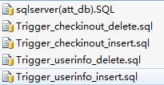
3. Installation and configuration
1) Installing ADMS
Double-click setup.exe to install, and restart the computer after installing. If you have any query about this, please read our ADMS User Manual, or email our technical support.
2) Creating database
Login SQL Server via SQL Server Management Studio, and pls create two database, one is adms_db and the other is att_db.
3) SQL Server database Configuration
Executing the file attsite.ini in iclockSvr folder, then you will see [DATABASE] there. We modify its info as your SQL Server info, so that we could connect our ADMS with SQL Server successfully. And I attached a screenshot of [DATABASE] as below:
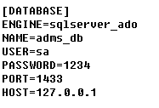
Please Note: You need modify the [DATABASE], not the [DATABASE_] module
Usually, we only need to modify its password when we install the ADMS and MS SQL Server in one PC. But if we installed the ADMS and MS SQL Server in different PC, then we also need to configure its HOST IP.
4) Creating database tables
Double-click file db.bat in installation folder iclockSvr\, it will go to create ADMS tables by itself. And we create a super user at last, as following,
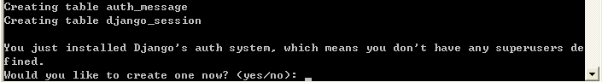
As upon image, we input yes. And then we create its Username and its password for super user, as below,
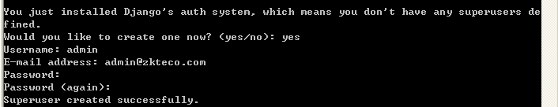
5) Creating Att2008 database tables
Double click sqlserver(att_db).sql which is in the attachment. We are going to create Att2008 tables in database att_db, like, and then click Execute. Then it will feedback its result at below of this MS SQL display.
6) Specified the database for Att2008:
Specified the database att_db as its database in Database Option in Att2008.
7) triggers
Refer to step 5), executing my attached sql files for database att_db. Now here are the explanation for other 4 sql files:
Trigger_userinfo_insert.sql, it is used to increase those synchronous user information.
Trigger_userinfo_delete.sql, it is used to delete those synchronous user information.
Trigger_checkinout_insert.sql, it is used to increase those synchronous attendance record.
Trigger_checkinout_delete.sql, it is used to delete those synchronous attendance record.
- Restart ADMS：
Restart ADMS services controller in the system task bar. ( We need to run iclockMng.exe as an administrator in the installation path of ADMS for those operating system, which has a permissions restrictions, like WIN7, Server 2008.)
4. Others
1) Software Compatibility
ADMS can't compatible with software Access5.0, Time8.0. We need to uninstall these two mentioned software totally before we install ADMS.
2) Running as administrator：
We need to run iclockMng.exe as an administrator in the installation path of ADMS for those operating system, which has a permissions restrictions, like WIN7, Server 2008. Here is its operation introduction: right-click ADMS icon in the taskbar, and we exit it, and then run iclockMng.exe as an administrator in its installation path.
3) The reboot operation is necessary
We have to reboot our PC after we uninstall or install the ADMS.
4) The data capacity of ADMS：
According to our estimation, this ADMS for MSSQL edition could handle the maximum 100 MB data daily, or we could say 2 million attendance record or 50000 fingerprint templates.
5) The ADMS could not read data which we download them via Att2008.

